Complaint Form (French Creole)
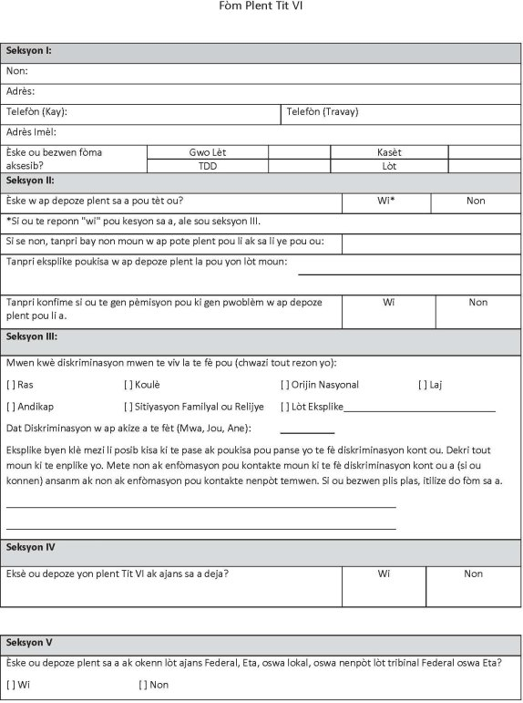

Complaint Form (French Creole)

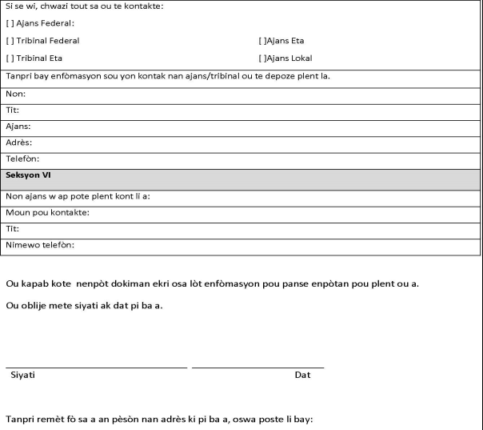

City of Fort Lauderdale,
Attn: Milos Majstorovic Title VI Coordinator
290 NE 3rd Avenue
Fort Lauderdale, FL 33301
954-828-5216

