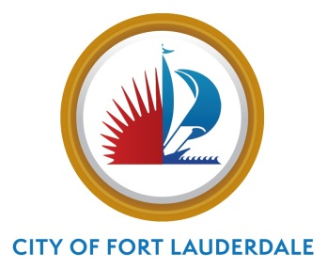

MEETING MINUTES

CITY OF FORT LAUDERDALE
  - NUISANCE ABATEMENT BOARD MINUTES
CITY HALL, CITY COMMISSION CHAMBERS
100 NORTH ANDREWS AVENUE
THURSDAY, JULY 14, 2022, 7:00 P.M.

Cumulative Attendance
1/2022 through 12/2022
Members | Attendance | Present | Absent
John Forman, Chair | P | 4 | 0
Joel Slotnick, Vice Chair | P | 4 | 0
Glen Lindsay | P | 3 | 1
Robert Phaneuf | P | 4 | 0

Avigdor Pemper A 1 1

Staff Present
Detective Jameson Jones
Joyce Hair, Board Clerk
Carla Blair, Recording Secretary, Prototype, Inc.

Communication to the City Commission

None.

Index
Item No. | Case Number | Respondent | Page
4. 21-08-02 2935 North Federal Highway, America’s Best – 2
Status Hearing

5. 22-04-01 301 SW 2nd Street, DBA #00 Shato – 2
Status Hearing

Purpose: Promote, protect, and improve the health, safety, and welfare of the citizens by imposing administrative fines and other non-criminal penalties in order to provide an equitable, expeditious, effective, and inexpensive method of enforcing ordinances under circumstances when a pending, or repeated violation continues to exist.

- Call meeting to order; Pledge of Allegiance

The meeting was called to order at 7:01 p.m. and the Pledge of Allegiance was recited.

- Roll call; witnesses sign log; swearing in

Roll was called and it was noted a quorum was present. Any individuals planning to speak at tonight’s meeting were sworn in.

- Approval of minutes for April 14, 2022

Motion made by Mr. Slotnick, seconded by Mr. Phaneuf, to approve the April minutes. In a voice vote, the motion passed unanimously.

Cases

- Case Number 21-08-02
2935 North Federal Highway
America’s Best
- Status Hearing

Detective Jameson Jones stated that since the prior meeting, there have been no nuisance-related reports initiated from this property. There were 36 calls for service, including a suspicious incident, a domestic incident, and requests to trespass individuals from the property, among others.

The property owner has asked when the Nuisance Abatement Board’s (NAB’s) jurisdiction is expected to end. Det. Jones noted that this may occur in September 2022. The Board members commented positively on improvements to the business’s appearance.

- Case Number 22-04-01
301 SW 2nd Street
DBA #00 Shato
- Status Hearing

Det. Jones reported that there were two calls for service from this property since the May 2022 meeting. He has spoken with the Patrol Officers who worked those shifts, who advised that the property has had no issues.

- Board Discussion

There being no further business to come before the Board at this time, the meeting was adjourned at 7:08 p.m.

Any written public comments made 48 hours prior to the meeting regarding items discussed during the proceedings have been attached hereto.

[Minutes prepared by K. McGuire, Prototype, Inc.]

